Analysing the ZEPTO Inventory Dataset Using PostgreSQL

Installing PostgreSQL
- Visit the official PostgreSQL website:
PostgreSQL Official Website
- Download the appropriate version for your operating system (Windows or Mac).
- Install PostgreSQL by following the setup instructions.

Dataset Download
Download the dataset from Kaggle:
Zepto Inventory Dataset on Kaggle

Creating a Server and Database in PostgreSQL

Step 1: Create a Server
Open PostgreSQL and create a new server.
Give the server a meaningful name based on your project.

Step 2: Create a Database
Inside the server, create a new database for the project.

Step 3: Enter Password
If prompted, enter the same password used during PostgreSQL installation.

Step 4: Open Query Tool
Under the created database:
- Right-click the database
- Select Query Tool to execute SQL queries

Dataset Formatting

Step 1: Extract the Dataset
- Download the dataset ZIP file
- Extract it to any folder
- Rename the folder if desired (example: Zepto Inventory)

Step 2: Convert to UTF-8 CSV
- Open the dataset in Excel
- Save the file as CSV UTF-8 Format
PostgreSQL works best with UTF-8 encoded CSV files, helping avoid import and encoding errors.

SQL Commands

Delete Table if it Already Exists
DROP TABLE IF EXISTS zepto;

Create the Table
CREATE TABLE zepto(
sku_id SERIAL PRIMARY KEY,
category VARCHAR(120),
name VARCHAR(150) NOT NULL,
mrp NUMERIC(8,2),
discountPercent NUMERIC(5,2),
availableQuantity INTEGER,
discountedSellingPrice NUMERIC(8,2),
WeightInGms INTEGER,
OutOfStock BOOLEAN,
quantity INTEGER
);

Importing the CSV Dataset into PostgreSQL
- Locate the zepto table in PostgreSQL.
- Right-click the table and select Import/Export Data.
- Browse and select the converted UTF-8 CSV file from your system.
- Configure the import settings if required:
  - Format: CSV
  - Encoding: UTF-8
  - Header: Enabled
- Click OK or Import to load the dataset into PostgreSQL successfully.

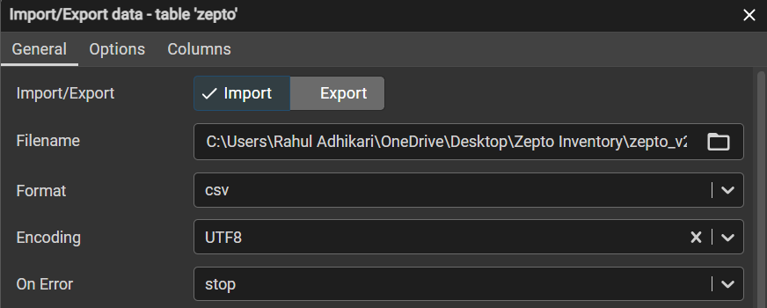

Import Configuration in PostgreSQL
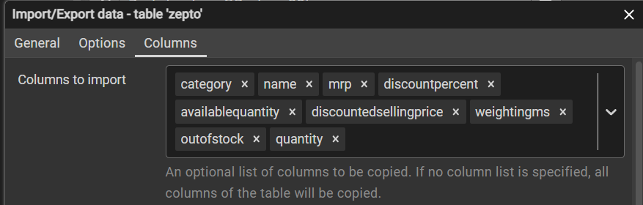
- Go to the Options section during the import process.
- Enable the Header option.
- In the Delimiter field, enter a comma ( , ).
- Under Columns to Import, remove sku_id if it already exists.
- Click OK to continue.
Once completed, PostgreSQL will display:
- Process Started
- Process Completed

Verifying Imported Data

Check Total Rows Imported
SELECT COUNT(*) FROM zepto;

View Sample Data
SELECT * FROM zepto
LIMIT 5;

Data Validation

Check for NULL Values
SELECT * FROM zepto
WHERE
name IS NULL
OR category IS NULL
OR mrp IS NULL
OR discountPercent IS NULL
OR availableQuantity IS NULL
OR discountedSellingPrice IS NULL
OR WeightInGms IS NULL
OR OutOfStock IS NULL
OR quantity IS NULL;

Exploratory Data Analysis (EDA)

Different Product Categories
SELECT DISTINCT category
FROM zepto
ORDER BY category;

Products In Stock vs Out of Stock
SELECT OutOfStock, COUNT(sku_id)
FROM zepto
GROUP BY OutOfStock;

Products Listed Multiple Times
SELECT name, COUNT(sku_id) AS "Number of SKUs"
FROM zepto
GROUP BY name
HAVING COUNT(sku_id) > 1
ORDER BY COUNT(sku_id) DESC;

Data Cleaning

Identify Products with Zero Pricing
SELECT * FROM zepto
WHERE mrp = 0
OR discountedSellingPrice = 0;

Delete Products Where MRP = 0
DELETE FROM zepto
WHERE mrp = 0;

Data Transformation
The product prices are stored in Paisa.
Since 100 Paisa = ₹1, convert the values into Rupees.

Convert Paisa to Rupees
UPDATE zepto
SET
mrp = mrp / 100.0,
discountedSellingPrice = discountedSellingPrice / 100.0;

Verify Updated Prices
SELECT mrp, discountedSellingPrice
FROM zepto;

Business Insights & Analysis

1. Top 10 Best-Value Products Based on Discount Percentage
SELECT DISTINCT name, mrp, discountPercent
FROM zepto
ORDER BY discountPercent DESC
LIMIT 10;

2. High MRP Products That Are Out of Stock
SELECT DISTINCT name, mrp
FROM zepto
WHERE mrp > 300
AND OutOfStock = TRUE
ORDER BY mrp DESC
LIMIT 10;

3. Calculate Revenue for Each Category
SELECT category,
SUM(discountedSellingPrice * availableQuantity) AS total_revenue
FROM zepto
GROUP BY category
ORDER BY total_revenue;

4. Products with MRP Greater Than ₹500 and Discount Less Than 10%
SELECT DISTINCT name, mrp, discountPercent
FROM zepto
WHERE mrp > 500
AND discountPercent < 10
ORDER BY mrp DESC, discountPercent DESC;

5. Top 5 Categories with Highest Average Discount
SELECT category,
ROUND(AVG(discountPercent), 2) AS avg_discount
FROM zepto
GROUP BY category
ORDER BY avg_discount DESC
LIMIT 5;

6. Best Value Products Based on Price Per Gram
SELECT DISTINCT name,
WeightInGms,
discountedSellingPrice,
ROUND(discountedSellingPrice / WeightInGms, 2) AS price_per_gram
FROM zepto
WHERE WeightInGms >= 100
ORDER BY price_per_gram;

7. Categorize Products Based on Weight
SELECT DISTINCT name,
WeightInGms,
CASE
WHEN WeightInGms < 1000 THEN 'Low'
WHEN WeightInGms < 5000 THEN 'Medium'
ELSE 'Bulk'
END AS weight_category
FROM zepto;

8. Total Inventory Weight per Category
SELECT category,
SUM(WeightInGms * availableQuantity) AS total_weight
FROM zepto
GROUP BY category
ORDER BY total_weight;

